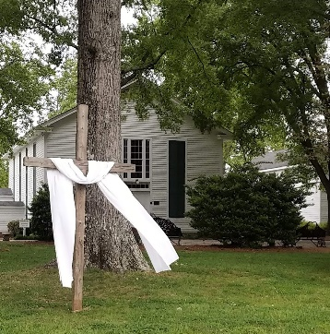

Director of Youth Ministries (non-ordained)
Position Description:
Providence Presbyterian Church has had an ongoing and active ministry to youth and their families and is seeking a person to continue and grow this ministry in creative and Christ-centered ways. The Director of Youth Ministries would be responsible for our ministry to youth from 6th to 12th grades, nurturing their spiritual development, fellowship, worship, service and mission.
This full-time position involves coordinating and developing a multi-dimensional ministry with our youth in church and community. A relational style of ministry is preferred as this person will be working alongside youth, their families, adult advisors, teachers and leaders. PPC is looking for a person who will provide friendship, encouragement, counsel, leadership and support to youth and their families. A deep and lived faith in Christ and the ability to communicate the joys and challenges of such faith is imperative.
It is REQUIRED that you have a whole lot of fun with this...be creative, be flexible, try new things, enjoy the youth and their families, and, did we mention: Have fun!
Qualifications and Responsibilities:
Education/Theology | Communication/Relationship
- Faith and integrity - ability to encourage spiritual growth and faith development in others | - A sense of call to Youth Ministry  - Compassion for working with families & youth  - Minister to youth/families in good times and stressful situations
- Working knowledge of Scripture and a basic understanding of reformed Christian theology | - Approachable, active listener with a sense of humor
- Ability to discuss various social and spiritual issues from a Christian perspective | - Thrive in a team environment but be a self-starter - initiate activities within the areas of responsibility of this ministry
- Formal education with bachelor’s degree from an accredited college or university; formal theological education a plus | - Create relationships with rising 6th graders and junior youth leaders
- Prefer 2+ years of experience working with youth in a spiritual, educational or recreational environment | - Maintain relationships with graduates, even after they leave for college or other
- Occasionally take part in the planning and/or teaching of Sunday School Classes  - Plan and oversee confirmation class with volunteer class leader | - Willingness to reach out to both churched and unchurched  - Actively engaging PPC Youth who are already involved while seeking and encouraging those who are not  - Actively recruiting families and youth outside the church who are looking to get involved.
 | - Maintain regular and consistent communication with families and youth with regards to ongoing calendar and events
Planning and Coordination | Administrative & Other Important Info
- Plan, organize and oversee all youth programs, including but not limited to: Sunday evening gatherings, community service projects, youth-lead worship services, retreats, mission trips and fun outings. | - Attends staff meetings, works with church staff to benefit all. Requires ability to work with a wide variety of people.  - Create & communicate youth calendar, coordinate with the general church calendar
- Collaborate closely with adult volunteer youth advisors and the Youth Council to plan and run events and coordinate the annual calendar. May require recruiting additional advisors as needed. | - Computer and social media skills such as: SignUpGenius, Facebook, Instagram, Basic web formatting, MS Office  - Desire and willingness to experiment with technology to better the Youth program
- Plan and work within an approved budget for expenditures. | - Personal and professional development through prayer, study, formal training events, conferences, etc.
- Plan and oversee fundraising activities for mission trips | - Coordinates vacation and study leave through church staff
- Oversees care of equipment that pertains to youth ministry | - Skilled in first aid techniques or be willing to receive such training  - Oversees the care and safety of youth during all events.
 | - Driver’s License & Passport required and the ability and willingness to travel locally, nationally and internationally
 | - a background check is required for which certain personal information is needed and will be treated with the strictest confidence.

10140 Providence Road, Charlotte, North Carolina 28277-9722 (704) 846-1079 ppc1767.org

