WORSHIP FOR THE LORD’S DAY

Thanks for worshiping with us. Whether you are with us from the pew or with us via your computer screen, we are so glad you’re here. Remember, worship is about God and we focus our eyes and hearts on the One who is before all things. At the same time, we know that when we gather, we receive gracious gifts and experience the love of Christ as one church. To prepare for worship, read the Words of Preparation; read and reflect upon the Scripture passage for today. Be intentional about connecting with God in your worship.

WORDS FOR PREPARATION:
“Humans have a responsibility to find themselves where which they belong, and to which they must inevitably contribute.” -Thomas Merton e they are, in their own proper time and place, in the history
PRELUDE “Toccata in C Major” J.S. Bach

WELCOME & ANNOUNCEMENTS

MOMENT OF MISSION

CALL TO WORSHIP
I will bless the Lord at all times,
God’s praise will continually be in my mouth.
My soul makes its boast in the Lord,
let the humble hear and be glad.
O magnify the Lord with me,
let us exalt God’s name together!

*HYMN #467 (verses 1-3) “How Great Thou Art”
*CALL TO CONFESSION
Let us confess our sins to God, who alone has the power to save and waits in mercy to forgive.
*PRAYER OF CONFESSION
Merciful God, we have not been humble. We have discouraged others from seeking you. We have not sought your wisdom. Forgive us, O God, and teach us to boast only of you. Help us to celebrate when others seek after you. Give us the light of your wisdom and ways, through Christ our Lord. Amen.
(Period of silence for personal confession)

*Assurance of Pardon
People of God, the Lord hears, forgives, and saves. Therefore, be reconciled to one another and walk humbly before God.
Thanks be to God.

*GLORIA PATRI
Glory be to the Father, and to the Son, and to the Holy Ghost; as it was in the beginning, is now,
and ever shall be, world without end.
Amen. Amen.

SPECIAL MUSIC “Be Thou My Vision” Carlton Young
PRAYERS OF THE PEOPLE

Prayer FOR ILLUMINATION

SCRIPTURE READING
Genesis 16
This is the Word of the Lord
Thanks be to God!

SERMON “At the Threshold: Hagar and the Desert” Rev. Candice Womack
*AFFIRMATION OF FAITH (Apostle’s Creed )
I believe in God, the Father Almighty, the Creator of heaven and earth, and in Jesus Christ, His
only, Son, our Lord, who was conceived of the Holy Spirit, born of the Virgin Mary, suffered under
Pontius Pilate, was crucified, died, and was buried. He descended into hell. The third day He arose
again from the dead. He ascended into heaven and sitteth at the right hand of God the Father
Almighty, from whence He shall come to judge the living and the dead. I believe in the Holy Spirit,
the holy catholic church, the communion of saints, the forgiveness of sins, the resurrection of the
body, and life everlasting.

SACRAMENT OF THE LORD’S SUPPER

….Our Father who art in heaven,
Hallowed be thy name.
Thy kingdom come.
Thy will be done
On earth as it is in heaven.
Give us this day our daily bread,
And forgive us our debts
as we forgive our debtors,
and lead us not into temptation,
but deliver us from evil.
For thine is the kingdom,
and the power, and the glory,
forever and ever.
Amen.

OFFERING OURSELVES AND OUR GIFTS
The Lord is indeed good, for God has blessed us richly. Let us offer back a portion, in gratitude and love.
GIVING OF OUR TITHES AND OFFERINGS

OFFERTORY: “Quartet on Kremser” Flor Peeters

(Please use this time for silent prayer and reflection as you consider ways to offer your life, your gifts, time, and commitment to God. You may give online at upctx.org/giving OR as you enter or exit the church sanctuary today. There are two offering boxes available. During the offertory, we will pass hats to collect offerings for our mission partners at Goodland Academy in Oklahoma.)
*THE DOXOLOGY
Praise God from whom all blessings flow; Praise Him all creatures here below; Praise Him above, Ye heavenly host; Praise Father, Son, and Holy Ghost. Amen.

*PRAYER OF DEDICATION
God, the creator of the universe, we offer to you these gifts for the glory of your kingdom,
in the name of God, the Father, Son, and Holy Spirit. Amen.

*HYMN #280 (vs 1-3) “Amazing Grace, How Sweet the Sound”

*BENEDICTION

*CONGREGATIONAL RESPONSE:
“Go now in peace. Never be afraid.
God will go with you each hour of every day.
Go now in faith, steadfast, strong and true.
Know He will guide you in all you do.
Go now in love, and show you believe.
Reach out to others so all the world can see.
God will be there watching from above.
Go now in peace, in faith, and in love.”

POSTLUDE: “Canzonetta in G Major” D. Buxtehude

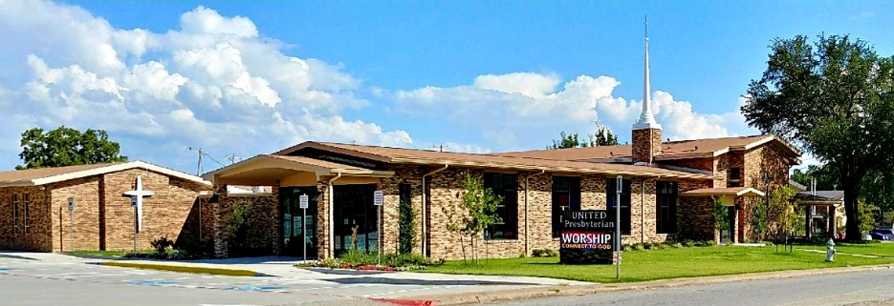

United Presbyterian Church

Rev. Candice Womack
5905 Stonewall Street
Greenville, Texas 75402

Sunday

June 6, 2021

Guided by the Word of God, led by the Holy Spirit, and
motivated by the love of Christ and all his people,
United Presbyterian Church, in intergenerational
community, celebrates God’s Glory by fostering Christian Growth.
Therefore, we value:
- Inviting and welcoming fellowship
- Bible-centered messages, music, and faith expressed through worship
- Commitment to our community

