WORSHIP FOR THE LORD’S DAY

Thanks for worshiping with us. Whether you are with us from the pew or with us via your computer screen, we are so glad you’re here. Remember, worship is about God and we focus our eyes and hearts on the One who is before all things. At the same time, we know that when we gather, we receive gracious gifts and experience the love of Christ as one church. To prepare for worship, read the Words of Preparation; read and reflect upon the Scripture passage for today. Be intentional about connecting with God in your worship.

WORDS FOR PREPARATION
God of the morning watches, my soul waits for you, and I hope in your word. Bread of life, nourish, strengthen, and accompany me throughout this day, that I may labor honestly, share with the needy, and imitate your love. Amen. -Feasting on the Word, Liturgies for Year B
PRELUDE “Prelude on Eat This Bread”

WELCOME & ANNOUNCEMENTS

CALL TO WORSHIP
I will bless the Lord at all times.
His praise shall continually be in my mouth.
O magnify the Lord with me,
and let us exalt God’s name together!

*HYMN (insert) “Here in This Place” (vs 1-3)
Glory to God #401

CHILDREN’S MESSAGE
(After the moment with children, they are invited to go to children’s church. Parents may pick them up afterwards.)
*CALL TO CONFESSION
Let us confess our sins to the One who hears our voice and is deeply moved by our distress.

*PRAYER OF CONFESSION
God of peace, we have rejected your redemption and forged our own way. We hang
between heaven and earth, caught up in our own folly. We have held fast to falsehood,
deceiving others and ourselves. We have sinned against you and done violence to others.
Our soul waits in hope for your word to redeem us so that we may begin anew, a new day
with you. Amen.
(Period of silence for personal confession)

*Assurance of Pardon
People of God, hope in the Lord! God in Christ has forgiven you. God has redeemed us from all
our iniquities through Christ, who loved us and gave himself for us as living bread for the life of
the world.

Thanks be to God.

*GLORIA PATRI
Glory be to the Father, and to the Son, and to the Holy Ghost; as it was in the beginning, is
now, and ever shall be, world without end. Amen. Amen.

PRAYERS OF THE PEOPLE AND THE LORD’S PRAYER

ANTHEM “How Firm a Foundation”
Prayer FOR ILLUMINATION

SCRIPTURE READING EPHESIANS 4:25-5:2
JOHN 6:35, 41-51
This is the Word of the Lord
Thanks be to God!

SERMON “Living Bread, Living in Love” Rev. Candice Womack

*AFFIRMATION OF FAITH (Theological Declaration of Barmen, 8.14)
As Jesus Christ is God’s assurance of the forgiveness of all our sins, so in the same way
and with the same seriousness is he also God’s mighty claim upon our whole life.
Through him befalls us a joyful deliverance from the godless fetters of this world for a
free, grateful service to his creatures.

OFFERING OURSELVES AND OUR GIFTS
Christ loved us and gave himself up for us. As beloved children, let us be imitators of God,
presenting our gifts as a fragrant offering and sacrifice, through Christ our Lord.

OFFERTORY “Elevation” Renee Vierne

GIVING OF OUR TITHES AND OFFERINGS
(Please use this time for silent prayer and reflection as you consider ways to offer your life, your gifts, time, and commitment to God. You may give online at upctx.org/giving OR as you enter or exit the church sanctuary today. There are two offering boxes available. During the offertory, we will collect the noisy offering: drop your loose change or other monetary gifts in the bowl! The noisy offering this month supports Bras for the Cause)
*THE DOXOLOGY
Praise God from whom all blessings flow; Praise Him all creatures here below; Praise Him above, Ye heavenly host; Praise Father, Son, and Holy Ghost. Amen.

*PRAYER OF DEDICATION
Generous, transforming God, thank you for the blessings through which you have provided these gifts in our hands to share with those in need. We dedicate them now as an expression of your love in the world, through Christ our Lord. Amen.
*HYMN #391 “Take My Life” (verses 1-3)

*BENEDICTION

*CONGREGATIONAL RESPONSE:
“Go now in peace. Never be afraid.
God will go with you each hour of every day.
Go now in faith, steadfast, strong and true.
Know He will guide you in all you do.
Go now in love, and show you believe.
Reach out to others so all the world can see.
God will be there watching from above.
Go now in peace, in faith, and in love.”

POSTLUDE: “Little Prelude and Fugue in C” J.S. Bach

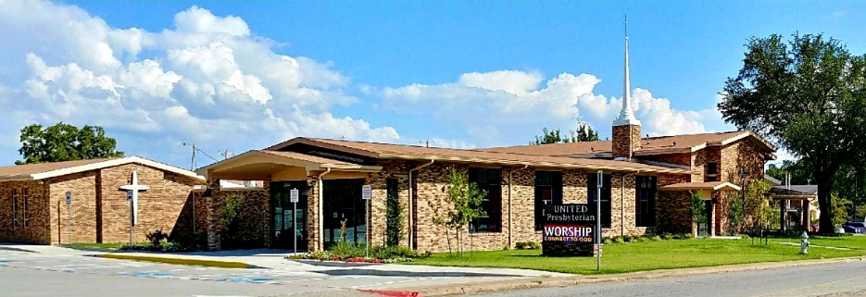

United Presbyterian Church

Rev. Candice Womack
5905 Stonewall Street
Greenville, Texas 75402

Eleventh Sunday After Pentecost

August 8, 2021

Guided by the Word of God, led by the Holy Spirit, and motivated by the love of Christ and all his people, United Presbyterian Church, in intergenerational community, celebrates God’s Glory by fostering Christian Growth.
Therefore, we value:
- Inviting and welcoming fellowship
- Bible-centered messages, music, and faith expressed through worship
- Commitment to our community

