WORSHIP FOR THE LORD’S DAY

Thanks for worshiping with us. Whether you are with us from the pew or with us via your computer screen, we are so glad you’re here. Remember, worship is about God and we focus our eyes and hearts on the One who is before all things. At the same time, we know that when we gather, we receive gracious gifts and experience the love of Christ as one church.

To prepare for worship, read the Words of Preparation; read
and reflect upon the Scripture passage for today. Be intentional about connecting with God in your worship.

WORDS FOR PREPARATION
God our Living Father, we give you thanks for sending our Lord Jesus Christ to give his life as bread for the world. Fill us now with your Spirit that we may make the most of the time, understanding your will and expressing your wisdom in the midst of the people you have chosen. Amen.
--Feasting on the Word, Liturgies for Year B

PRELUDE “Prelude in D Major” J.S.Bach
WELCOME AND ANNOUNCEMENTS

CALL TO WORSHIP
The God of wisdom sent Jesus Christ,
the bread of life,
to teach us his ways,
and fill us with the Holy Spirit.

Thanks be to God!

*HYMN (insert) “Here in This Place” (vs 1 and 3)
Glory to God #401

CHILDREN’S MESSAGE

*CALL TO CONFESSION
Let us confess our sins to the all-wise God who is gracious and merciful and keeps covenant with us.

*PRAYER OF CONFESSION
All-knowing God, we are your children, but we have turned away from your wisdom and walked in our own ways. We have lived carelessly and squandered time. We have been foolish and failed to understand your will. Clear our minds from clutter that we may discern what is right and walk in your ways. Amen.
(Period of silence for personal confession)

*Assurance of Pardon
The Lord is gracious and merciful! God shows great and steadfast love to us through Jesus Christ, our bread of life. By his flesh and blood our sins are forgiven and we have eternal life.
Thanks be to God!

*GLORIA PATRI
Glory be to the Father, and to the Son, and to the Holy Ghost; as it was in the beginning, is now, and ever shall be, world without end. Amen. Amen.

PRAYERS OF THE PEOPLE AND THE LORD’S PRAYER

Our Father who art in heaven….

SPECIAL MUSIC “Prayer” Schubert/Liszt

PRAYER FOR ILLUMINATION

SCRIPTURE READING 1 Kings 2:10-12; 3:3-14 Psalm 111

The word of the Lord!
Thanks be to God.

SERMON “Wisdom”
*AFFIRMATION OF FAITH (Excerpt from Romans 8)
We believe there is no condemnation for those that are in Christ Jesus, for we know that all things work together for good for those who love God, and who are called according to God’s purpose. We are convinced that neither death nor life, nor angels, nor rulers, nor things present nor things to come, nor powers or height or depth or anything in all of creation will be able to separate us from the love of God in Christ Jesus our Lord. Amen.

OFFERING OURSELVES AND OUR GIFTS
Christ, our living bread, has given his flesh for the life of the world, filled with the Spirit, let us offer our gifts of thanksgiving to God through our Lord Jesus Christ.
GIVING OF OUR TITHES AND OFFERINGS
(Please use this time for silent prayer and reflection as you consider ways to offer your life, your gifts, time, and commitment to God. You may give online at upctx.org/giving OR as you enter or exit the church sanctuary today. There are two offering boxes available.)
OFFERTORY “O Sacrum Convivium” are. Gerald Near

*THE DOXOLOGY
Praise God from whom all blessings flow; Praise Him all creatures here below; Praise Him above, Ye heavenly host; Praise Father, Son, and Holy Ghost. Amen.

* PRAYER OF DEDICATION
We give thanks to you, O God, for sending your Son Jesus to be living bread for the world. Breathe on these gifts we bring, that through them your life may feed, strengthen, and bless this world, through Jesus Christ, our bread of life. Amen.

*HYMN #339 “Be Thou My Vision”
*BENEDICTION

*CONGREGATIONAL RESPONSE
“Go now in peace. Never be afraid.
God will go with you each hour of every day.
Go now in faith, steadfast, strong and true.
Know He will guide you in all you do.
Go now in love, and show you believe.
Reach out to others so all the world can see.
God will be there watching from above.
Go now in peace, in faith, and in love.”

POSTLUDE “Allegro Maestoso” F. Mendelssohn
www.upctx.org

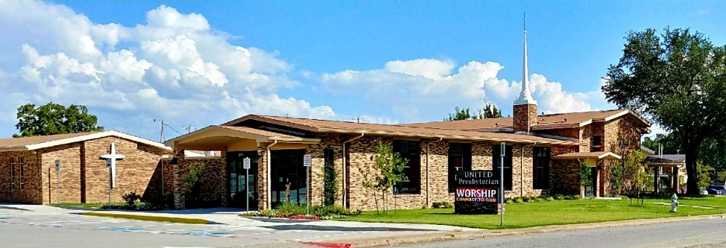

United Presbyterian Church

Rev. Candice Womack
5905 Stonewall Street
Greenville, Texas 75402

Twelfth Sunday after Pentecost

August 15, 2021

Guided by the Word of God, led by the Holy Spirit, and motivated by the love of Christ and all his people, United Presbyterian Church, in intergenerational community, celebrates God’s Glory by fostering Christian Growth.
Therefore, we value:
- Inviting and welcoming fellowship
- Bible-centered messages, music, and faith expressed through worship
- Commitment to our community

