WORSHIP FOR THE LORD’S DAY

Thanks for worshiping with us. Whether you are with us from the pew or with us via your computer screen, we are so glad you’re here. Remember, worship is about God and we focus our eyes and hearts on the One who is before all things. At the same time, we know that when we gather, we receive gracious gifts and experience the love of Christ as one church.

To prepare for worship, read the Words of Preparation; read
and reflect upon the Scripture passage for today. Be intentional about connecting with God in your worship.

WORDS FOR PREPARATION
We often try to put God in a box. The God who fits in our boxes isn't the God & Father of our Lord Jesus Christ. -A.W. Tozer
PRELUDE “Motet on “St. Patrick’s Breastplate” Anonymous
WELCOME AND ANNOUNCEMENTS

CALL TO WORSHIP
I will bless the Lord at all times;
his praise shall ever be in my mouth.
My soul shall glory in the Lord;
let the humble hear and be glad.
O magnify the Lord within me;
let us exalt his name together.
I sought the Lord and he answered me
and delivered me from all my fears.
Let us taste and see that the Lord is good!
*HYMN (insert) “Here in This Place” (vs 1,2, 3)
Glory to God #401

CHILDREN’S MESSAGE

*CALL TO CONFESSION
Let us approach with a true heart in full assurance of faith, with our hearts sprinkled clean from an evil conscience and our bodies washed with pure water. Let us hold fast to the confession of our hope without wavering, for the one who has promised is faithful.

*PRAYER OF CONFESSION
God, forgive us. Our communion is not always visible to the world. We act as though we do not need each other. We do not always love one another. We do not know and bear one another’s burdens. We fail to build each other up. We do not always give ourselves willingly and joyfully to one another. Forgive us and strengthen us so that we may live in love in the community that you have given us.
(Period of silence for personal confession)

*Assurance of Pardon
By Christ’s work, we are reconciled and united with God and with one another. Thanks be to God for the Good News:
In Jesus Christ, we are forgiven. Amen.
*GLORIA PATRI
Glory be to the Father, and to the Son, and to the Holy Ghost; as it was in the beginning, is now, and ever shall be, world without end. Amen. Amen.

PRAYERS OF THE PEOPLE AND THE LORD’S PRAYER

Our Father who art in heaven….

PRAYER FOR ILLUMINATION

SCRIPTURE READING Ephesians 6:10-20
The word of the Lord!
Thanks be to God.

SERMON “Dress Code” Rev .Candice Womack
*AFFIRMATION OF FAITH (Confession of 1967,9.21,22)
The reconciling work of Jesus was the supreme crisis in the life of humankind. His cross and resurrection become personal crisis and present hope for all when the gospel is proclaimed and believed. In this experience, the Spirit brings God’s forgiveness to people, moves people to respond in faith, repentance, and obedience, and initiates the new life in Christ. The new life takes shape in a community in which we know that God loves and accepts us in spite of what we are. We therefore accept ourselves and love others, knowing that no one has any ground on which to stand, except God’s grace.

OFFERING OURSELVES AND OUR GIFTS
The earth is the Lord’s, and all that is in it, the world, and those who live in it. Let us return to God the offerings of our life and the gifts of the earth.
GIVING OF OUR TITHES AND OFFERINGS
(Please use this time for silent prayer and reflection as you consider ways to offer your life, your gifts, time, and commitment to God. You may give online at upctx.org/giving OR as you enter or exit the church sanctuary today. There are two offering boxes available.)
OFFERTORY “Verset” Marcel Dupre

*THE DOXOLOGY
Praise God from whom all blessings flow; Praise Him all creatures here below; Praise Him above, Ye heavenly host; Praise Father, Son, and Holy Ghost. Amen.

* PRAYER OF DEDICATION
Gracious God, how can we thank you for such a gift as has been given to us through Christ Jesus our Lord? For you have drawn us to you in grace and bound us to one another. Send us out to share your love and proclaim your hope until Christ comes again. Bless the gifts we have offered back to you and help us to use them according to your call.
*HYMN (insert) “Standing on the Promises of God”
(Glory to God #838 vs 1-4)
*BENEDICTION

*CONGREGATIONAL RESPONSE
“Go now in peace. Never be afraid.
God will go with you each hour of every day.
Go now in faith, steadfast, strong and true.
Know He will guide you in all you do.
Go now in love, and show you believe.
Reach out to others so all the world can see.
God will be there watching from above.
Go now in peace, in faith, and in love.”

POSTLUDE “A Mighty Fortress” Helmut Walcha
www.upctx.org

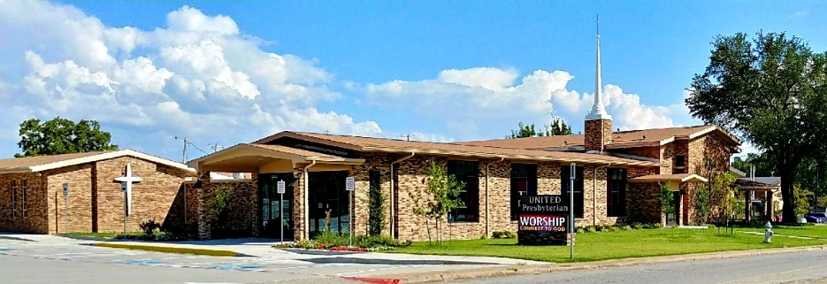

United Presbyterian Church

Rev. Candice Womack
5905 Stonewall Street
Greenville, Texas 75402

Thirteenth Sunday after Pentecost

August 22, 2021

Guided by the Word of God, led by the Holy Spirit, and motivated by the love of Christ and all his people, United Presbyterian Church, in intergenerational community, celebrates God’s Glory by fostering Christian Growth.
Therefore, we value:
- Inviting and welcoming fellowship
- Bible-centered messages, music, and faith expressed through worship
- Commitment to our community

