WORSHIP FOR THE LORD’S DAY

Thanks for worshiping with us. Whether you are with us from the pew or with us via your computer screen, we are so glad you’re here. Remember, worship is about God and we focus our eyes and hearts on the One who is before all things. At the same time, we know that when we gather, we receive gracious gifts and experience the love of Christ as one church.

To prepare for worship, read the Words of Preparation; read
and reflect upon the Scripture passage for today. Be intentional about connecting with God in your worship.

WORDS FOR PREPARATION
For now we see the beauty of God through a glass, darkly, but then face to face; now we appreciate only in part, but then we shall affirm and appreciate God, even as the living God has affirmed and appreciated us. So now our tasks are worship, mission, and management, these three; but the greatest of these is worship. – N.T. Wright
PRELUDE “Lo, the Winter is Past” Marcel Dupre
WELCOME AND ANNOUNCEMENTS

CALL TO WORSHIP
God has lavished us with every perfect gift
from above
and called us to living intimacy through the
beloved one, Jesus Christ our Lord.

*HYMN (insert) “Here in This Place” (vs 1,2, 3)
Glory to God #401

CHILDREN’S MESSAGE

*CALL TO CONFESSION
Let us confess our sins to our loving God who calls us close through our beloved Savior, Jesus Christ our Lord.

*PRAYER OF CONFESSION
Loving, righteous God, you have called us to yourself, but we have gone away. Forgetting your living Word, we cling to dead traditions. Deceiving ourselves, we abandon your commandments. Cleanse our hearts from evil intentions and cleanse our tongues from evil words so that our worship may be pure and we may live in love for others. Amen.
(Period of silence for personal confession)

*Assurance of Pardon
Our generous God has given us the perfect gift of forgiveness: Jesus Christ our Lord. We have been made new by God’s love.
Thanks be to God!
*GLORIA PATRI
Glory be to the Father, and to the Son, and to the Holy Ghost; as it was in the beginning, is now, and ever shall be, world without end. Amen. Amen.

PRAYERS OF THE PEOPLE AND THE LORD’S PRAYER

Our Father who art in heaven….

SPECIAL MUSIC “Swing Low, Sweet Chariot” Handbells

PRAYER FOR ILLUMINATION

SCRIPTURE READING James 1:17-27
Mark 7:1-8, 14-15, 21-23
The word of the Lord!
Thanks be to God.

SERMON “The Looking Glass” Rev .Candice Womack
*AFFIRMATION OF FAITH (Confession of Belhar)
We believe… that Christ's work of reconciliation is made manifest in the church as the community of believers who have been reconciled with God and with one another; that unity is, therefore, both a gift and an obligation for the church of Jesus Christ; that through the working of God's Spirit it is a binding force, yet simultaneously a reality which must be earnestly pursued and sought: one which the people of God must continually be built up to attain…

OFFERING OURSELVES AND OUR GIFTS
Every generous act of giving, with every perfect gift, is from above, coming down from the Father of lights. Filled with God’s generosity, let us offer our gifts with gladness through Jesus Christ our Lord.
GIVING OF OUR TITHES AND OFFERINGS
(Please use this time for silent prayer and reflection as you consider ways to offer your life, your gifts, time, and commitment to God. You may give online at upctx.org/giving OR as you enter or exit the church sanctuary today. There are two offering boxes available.)
OFFERTORY “Let All Things Now Living” Frank Stoldt

*THE DOXOLOGY
Praise God from whom all blessings flow; Praise Him all creatures here below; Praise Him above, Ye heavenly host; Praise Father, Son, and Holy Ghost. Amen.

* PRAYER OF DEDICATION
Living God, thank you for your gifts of life – fragrant flowers, fruitful vines, singing creatures, and our own lives, renewed in Christ. Let your grace infuse the gifts we offer with life-giving power for those in need. In the name of the Father and of the Son and of the Holy Spirit. Amen.
*HYMN#434 “Today We All Are Called to Be Disciples”
(verses 1-3)
*BENEDICTION

*CONGREGATIONAL RESPONSE
“Go now in peace. Never be afraid.
God will go with you each hour of every day.
Go now in faith, steadfast, strong and true.
Know He will guide you in all you do.
Go now in love, and show you believe.
Reach out to others so all the world can see.
God will be there watching from above.
Go now in peace, in faith, and in love.”

POSTLUDE “Rejoice, Ye Pure In Heart” Robert J. Powell
www.upctx.org

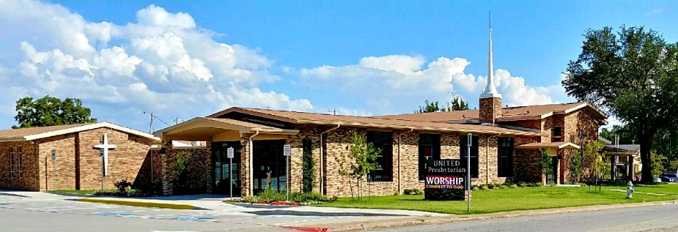

United Presbyterian Church

Rev. Candice Womack
5905 Stonewall Street
Greenville, Texas 75402

Fourteenth Sunday after Pentecost

August 29, 2021

Guided by the Word of God, led by the Holy Spirit, and motivated by the love of Christ and all his people, United Presbyterian Church, in intergenerational community, celebrates God’s Glory by fostering Christian Growth.
Therefore, we value:
- Inviting and welcoming fellowship
- Bible-centered messages, music, and faith expressed through worship
- Commitment to our community

