WORSHIP FOR THE LORD’S DAY

Thanks for worshiping with us. Whether you are with us from the pew or with us via your computer screen, we are so glad you’re here. Remember, worship is about God and we focus our eyes and hearts on the One who is before all things. At the same time, we know that when we gather, we receive gracious gifts and experience the love of Christ as one church. To prepare for worship, read the Words of Preparation; read and reflect upon the Scripture passage for today. Be intentional about connecting with God in your worship.

WORDS FOR PREPARATION:
“It’s a mistake to think that we have to be lovely to be loved by human beings or
by God.” -Fred Rogers

PRELUDE “Duet” Mendelssohn

WELCOME & ANNOUNCEMENTS

MOMENT FOR MISSION
CALL TO WORSHIP
Our merciful God, maker of us all,
pleads the cause of the poor and afflicted.
Open our hearts to demonstrate God’s grace
through Jesus Christ our Lord.

*HYMN #439 “In Christ There is No East or West”

CHILDREN’S MESSAGE

*CALL TO CONFESSION
Let us confess our sins to the Lord who surrounds us with favor forevermore.

*PRAYER OF CONFESSION
God of favor, we have not been true to you. You have chosen the poor in the world, but we have dishonored them. You plead the cause of the afflicted, but we crush them. We have not loved our neighbors as ourselves. We have dismissed the needy with empty words. Soften our hearts and make straight our ways, heal our unbelief and turn us back to you. Amen.

(Period of silence for personal confession)

*Assurance of Pardon
The mercy of our God triumphs over judgment through our glorious Lord Jesus Christ,
who has pleaded our cause, forgiven our sin, healed our sickness, and delivered us
from evil.

Thanks be to God.

*GLORIA PATRI
Glory be to the Father, and to the Son, and to the Holy Ghost; as it was in the beginning, is
now, and ever shall be, world without end. Amen. Amen.

PRAYERS OF THE PEOPLE

ANTHEM

Prayer FOR ILLUMINATION

SCRIPTURE READING James 2:10-10, 14-17

This is the Word of the Lord
Thanks be to God!

SERMON “The One Where You Love Your Neighbor” Rev. Candice Womack

*AFFIRMATION OF FAITH (Apostle’s Creed )
I believe in God, the Father Almighty, the Creator of heaven and earth, and in Jesus Christ,
His only, Son, our Lord, who was conceived of the Holy Spirit, born of the Virgin Mary,
suffered under Pontius Pilate, was crucified, died, and was buried. He descended into hell.
The third day He arose again from the dead. He ascended into heaven and sitteth at the
right hand of God the Father Almighty, from whence He shall come to judge the living and
the dead. I believe in the Holy Spirit, the holy catholic church, the communion of saints, the
forgiveness of sins, the resurrection of the body, and life everlasting.

SACRAMENT OF THE LORD’S SUPPER
Invitation and Words of Institution
Communion
Hymn #513 “Let Us Break Bread Together”
Prayer and the Lord’s Prayer
….Our Father who art in heaven,

OFFERING OURSELVES AND OUR GIFTS
Those who are generous are blessed through the good name of Jesus Christ our Savior,
by whom we have received the favor of God—better than silver or gold. From the
riches of God’s grace, let us present our gifts of gratitude to bless those in need.

GIVING OF OUR TITHES AND OFFERINGS

OFFERTORY Prelude on “In Christ There Is No East or West” Jonathon Biery

(Please use this time for silent prayer and reflection as you consider ways to offer your
life, your gifts, time, and commitment to God. You may give online at upctx.org/giving
OR as you enter or exit the church sanctuary today. There are two offering boxes
available. Today we also invite you to give to our special offering for Goodland
Academy. Hats will be provided at the sanctuary exits to give to our mission partners at
Goodland Academy in Oklahoma.)

*THE DOXOLOGY
Praise God from whom all blessings flow; Praise Him all creatures here below; Praise Him above, Ye heavenly host; Praise Father, Son, and Holy Ghost. Amen.

*PRAYER OF DEDICATION
Generous God, thank you for these gifts we bring from your abundance. Bless gifts
and givers to show your love to all those in need through our Lord Jesus Christ,
healer of the sick, advocate of the afflicted, provider for the poor. Amen.

*HYMN (insert) “Make Me a Channel of Your Peace”
Glory to God #753
*BENEDICTION

*CONGREGATIONAL RESPONSE:
“Go now in peace. Never be afraid.
God will go with you each hour of every day.
Go now in faith, steadfast, strong and true.
Know He will guide you in all you do.
Go now in love, and show you believe.
Reach out to others so all the world can see.
God will be there watching from above.
Go now in peace, in faith, and in love.”

POSTLUDE: ‘Fiddle’ Fugue in D minor J.S. Bach

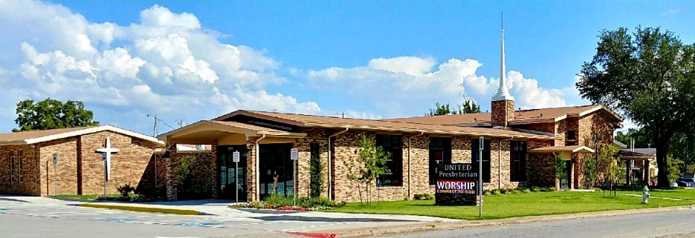

United Presbyterian Church

Rev. Candice Womack
5905 Stonewall Street
Greenville, Texas 75402

Fifteenth Sunday After Pentecost

September 5, 2021

Guided by the Word of God, led by the Holy Spirit, and
motivated by the love of Christ and all his people,
United Presbyterian Church, in intergenerational
community, celebrates God’s Glory by fostering Christian Growth.
Therefore, we value:
- Inviting and welcoming fellowship
- Bible-centered messages, music, and faith expressed through worship
- Commitment to our community

