WORSHIP FOR THE LORD’S DAY

Thanks for worshiping with us. Whether you are with us from the pew or with us via your computer screen, we are so glad you’re here. Remember, worship is about God and we focus our eyes and hearts on the One who is before all things. At the same time, we know that when we gather, we receive gracious gifts and experience the love of Christ as one church. To prepare for worship, read the Words of Preparation; read and reflect upon the Scripture passage for today. Be intentional about connecting with God in your worship.

WORDS FOR PREPARATION
It says in the Bible, O God, that you created the world through your Word. Your Word is powerful! And so are our words. They can heal, create a smile, be a declaration of love; but they can also hurt and destroy a sense of self-worth. Give us your wisdom, God of the Word, so that as a church and as individuals, we use our words to build up and not to destroy. Amen. -Feasting on the Word, Liturgies for Year B

PRELUDE “These Are the Holy Ten Commandments” (Canon) J.S. Bach

WELCOME & ANNOUNCEMENTS

CALL TO WORSHIP
Look at the heavens!
They are shouting the glory of God.
The days and the nights declare the magnificence
of God’s creative works.
Their voice goes through all the earth
and their words reach the ends of the world.
Let our words of praise be acceptable to you.
Our Lord, our rock, our redeemer!

*HYMN #469 “Morning Has Broken”

CHILDREN’S MESSAGE
*CALL TO CONFESSION
Let us use our voices to declare those things we have said and done that have separated us
from God, and from each other, that we may experience God’s mercy and receive God’s
forgiveness.

*PRAYER OF CONFESSION
You have called us, O God, and we have refused to listen; you have stretched out your
hand and we have not taken it. We have taken what you have given us and used those
gifts to hurt others and defy you. We have refused to be tamed by your wisdom. Forgive
our inability to recognize you and live out the reality of your gospel.

(Period of silence for personal confession)

*Assurance of Pardon
The law of the Lord is perfect, and it revives the soul; the decrees of the Lord are sure and make
wise the simple; the precepts of the Lord are right, rejoicing the heart; the commandment of the
Lord is clear, and it enlightens the eyes. Hear the good news! In Jesus Christ, the living Word,
we are forgiven.

Thanks be to God.

*GLORIA PATRI
Glory be to the Father, and to the Son, and to the Holy Ghost; as it was in the beginning, is
now, and ever shall be, world without end. Amen. Amen.

PRAYERS OF THE PEOPLE AND THE LORD’S PRAYER

SPECIAL MUSIC: “Madrid” Bell Tree and Piano
Prayer FOR ILLUMINATION

SCRIPTURE READING James 3:1-12

This is the Word of the Lord
Thanks be to God!

SERMON “Bridles, Bits, Blessing and Curse” Rev. Candice Womack

*AFFIRMATION OF FAITH (Theological Declaration of Barmen, 8.14)
As Jesus Christ is God’s assurance of the forgiveness of all our sins, so in the same way
and with the same seriousness is he also God’s mighty claim upon our whole life.
Through him befalls us a joyful deliverance from the godless fetters of this world for a
free, grateful service to his creatures.

OFFERING OURSELVES AND OUR GIFTS
God has given us the sun and made us stewards of all creation. God has given us our lives and our very beings. Let us give to God, from what God has given us.

OFFERTORY “Our Father Who Art in Heaven” J.S. Bach

GIVING OF OUR TITHES AND OFFERINGS
(Please use this time for silent prayer and reflection as you consider ways to offer your life, your gifts, time, and commitment to God. You may give online at upctx.org/giving OR as you enter or exit the church sanctuary today. There are two offering boxes available. During the offertory, we will collect the noisy offering: drop your loose change or other monetary gifts in the bowl! The noisy offering this month supports Bras for the Cause)
*THE DOXOLOGY
Praise God from whom all blessings flow; Praise Him all creatures here below; Praise Him above, Ye heavenly host; Praise Father, Son, and Holy Ghost. Amen.

*PRAYER OF DEDICATION
God of wisdom, may this offering serve as a powerful witness to this world in need. Guide us as we administer the gifts that you have given us for the building of your kingdom. In Jesus Christ we pray. Amen.
*HYMN #454 “Blessed Jesus, At Your Word”

*BENEDICTION

*CONGREGATIONAL RESPONSE:
“Go now in peace. Never be afraid.
God will go with you each hour of every day.
Go now in faith, steadfast, strong and true.
Know He will guide you in all you do.
Go now in love, and show you believe.
Reach out to others so all the world can see.
God will be there watching from above.
Go now in peace, in faith, and in love.”

POSTLUDE: “These Are the Holy Ten Commandments” (Gigue) J.S. Bach

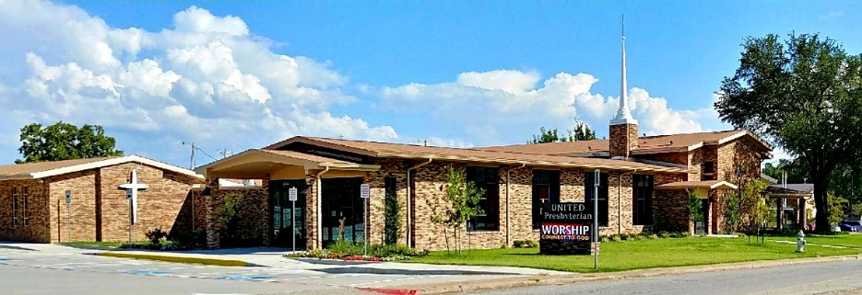

United Presbyterian Church

Rev. Candice Womack
5905 Stonewall Street
Greenville, Texas 75402

Sixteenth Sunday After Pentecost

September 12, 2021

Guided by the Word of God, led by the Holy Spirit, and motivated by the love of Christ and all his people, United Presbyterian Church, in intergenerational community, celebrates God’s Glory by fostering Christian Growth.
Therefore, we value:
- Inviting and welcoming fellowship
- Bible-centered messages, music, and faith expressed through worship
- Commitment to our community

