Living Good Friday
Good Friday
April 10, 2020
Bishop Sue Briner
Southwestern Texas Synod, ELCA

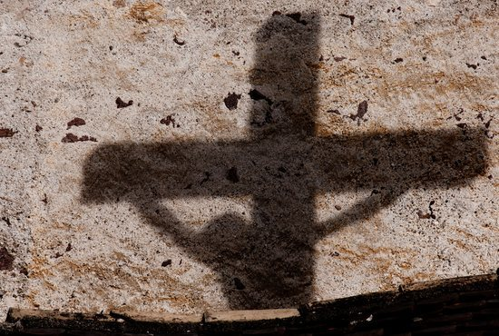

Grace to you and peace, from God the Father, our Lord Jesus Christ and the Holy Spirit, on this Friday that seems anything but good.

The world appears to be coming apart in all sorts of ways, as the coronavirus spreads exponentially, wreaking havoc on just about everything we have always taken for granted. The body count is rising, and we are only at the beginning of the crisis here in the US. Businesses have closed, workers are furloughed, our church buildings have been shuttered for the foreseeable future.

As we are ensconced in our homes, fearful of what we cannot see, anxious about what comes next it feels like we are living Good Friday in our bodies and souls right now. Death and darkness are all around us, and threaten to overtake us. We are grieving for what we have already lost and what we might lose in the future.

We may hope and pray that this death of life as we know it lasts no longer than the three days of the Triduum but the minute by minute news updates tell us that this is going to get much worse before it gets better. And we have no idea what life will be like on the other side of this pandemic.

We are in a place of lamentation. It’s not a place we’re used to hanging out in for very long. We want to get on with Easter already. We are impatient, used to having our own way, controlling our environment to a certain degree, and now everything seems out of control. We are living Good Friday in our bodies and souls.

Perhaps we can read Psalm 22, one of our texts for this day, as our collective cry of pain:

Our God, our God, why have you forsaken us? Why are you so far from saving us, from the words of our groaning? Our God, we cry out by day, but you do not answer; by night, but we find no rest.

I don’t know about you, but I’ve had a lot of dark and restless nights of the soul since all this began, and sometimes it’s hard to keep the anxiety and even despair at bay.

In our long reading from the gospel of John for this Friday, we hear the story of Jesus’ arrest, interrogation, torture, crucifixion, death and burial. We are reminded in this passage that there is no human circumstance that is beyond the reach of God’s direct experience or understanding.

When we might wonder if God has forsaken us, Christ’s death on the cross is where we look. Here, in the midst of undeserved pain, suffering and death, is where God meets us, and God pours out God’s love for us. God reminds us in the cross of Christ that God stands in solidarity with all human suffering, and that even in death, God is not powerless. Jesus said from the cross “it is finished,” and handed over his life willingly, for the sake of the world God loves so completely.

As we look to the cross, we can speak more words of Psalm 22, in the midst of our lamentation, saying to God:

Yet you alone are the Holy One. Our ancestors put their trust in you, and you rescued them. You are the one who drew me forth from the womb and kept me safe at my mother’s breast. I have been entrusted to you ever since I was born; you were my God when I was still in my mother’s womb.

This same God who formed us, who created us, is with us always. Live Good Friday in your bodies and souls as you remember who God is and whose we are as baptized children of God, part of the body of Christ, wounds and all.

As we travel together through this Holy Week and this pandemic, we remember that we are Christ’s body, crucified for the sake of the world. Just as Christ stands in solidarity with us in our suffering, so too we are called to stand in solidarity with others.

As we are trapped in our homes, we stand in solidarity with those who have been shut in or locked up for much longer than we have, and we get a taste of what isolation and confinement are like. As we get anxious about whether there will be enough food at the grocery store, we stand in solidarity with those who are chronically anxious about where their next meal will come from.

As we might be losing our income or our retirement fund is decreasing, we stand in solidarity with those in poverty and without a safety net. As we may suffer symptoms of depression, we stand in solidarity with those with chronic mental health issues. In our corporate suffering, we stand in solidarity with individuals and communities who endure daily pain and grief. This pandemic gives us the opportunity to experience what those who have less privilege than we do deal with on a regular basis.

How might our suffering open our eyes and hearts to be more compassionate toward others?

How might our suffering better equip us to be the hands of Christ in this world?

And we remember that, unlike those disciples who were grieving the death of their friend and leader and did not know what would happen next, we know the rest of the story. We know that there is resurrection life after Good Friday. That new life will look different from the life we are living now. We don’t know when it will come or what it will bring, but we trust in God’s gracious intention for all creation. So even as we lament and wait in darkness, we trust that Easter is coming and that God will bring new life out of whatever death and darkness our world is currently experiencing. We live Good Friday in our bodies and souls, trusting in the sure and certain hope of the presence and power of God.

May we all be strengthened and sustained in our Good Friday living. Amen.

