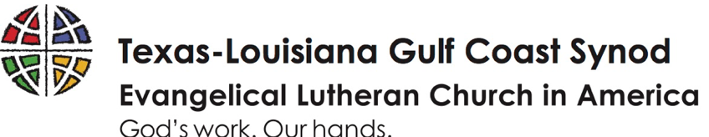
In the aftermath of our unprecedented ice storm and record low temperatures, individuals and congregations throughout the synod face multiple crises: food insecurity, homelessness, gutting and renovation. Not all have insurance or the means to afford hotels. Food has spoiled due to lack of power, impacting the most vulnerable. All this exacerbated the humanitarian crisis already taking place due to COVID.
When we can repair all that is damaged, we will continue to be a community of faith gathered by the love of God and our neighbors can continue working in the kingdom of God, allowing ourselves to be used by the Spirit of God to touch the lives of our community and its surroundings.
~ Rev. Adriana Johnson-Rivas, Prince of Peace Lutheran Church, Houston

We still have families dealing with water break issues… once one break is fixed, another explodes as the water system pressurizes. We have folks needing to choose which bill to pay as they struggle to make it day to day. Before the freeze we had many hurting families in the community, the freeze has only exacerbated the number of families. How can we not respond when we see our sisters and brothers in need?

~ Rev. Richard Rhoades, First Lutheran Church, Galveston
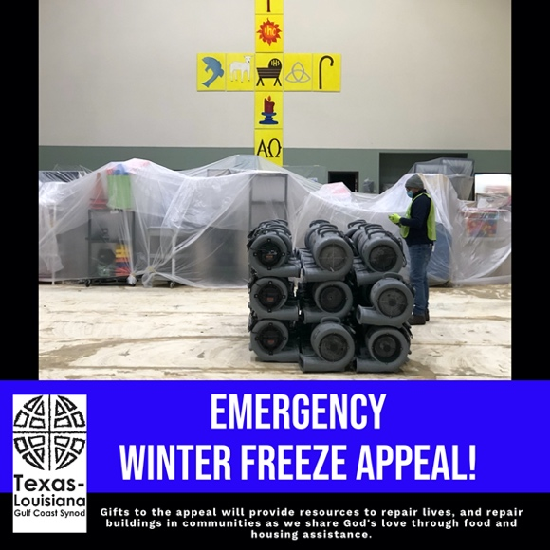

In the aftermath of our unprecedented ice storm and record low temperatures, individuals and congregations throughout the synod face multiple crises: food insecurity, homelessness, gutting and renovation. Not all have insurance or the means to afford hotels. Food has spoiled due to lack of power, impacting the most vulnerable. All this exacerbated the humanitarian crisis already taking place due to COVID.
When we can repair all that is damaged, we will continue to be a community of faith gathered by the love of God and our neighbors can continue working in the kingdom of God, allowing ourselves to be used by the Spirit of God to touch the lives of our community and its surroundings.
~ Rev. Adriana Johnson-Rivas, Prince of Peace Lutheran Church, Houston

We still have families dealing with water break issues… once one break is fixed, another explodes as the water system pressurizes. We have folks needing to choose which bill to pay as they struggle to make it day to day. Before the freeze we had many hurting families in the community, the freeze has only exacerbated the number of families. How can we not respond when we see our sisters and brothers in need?

~ Rev. Richard Rhoades, First Lutheran Church, Galveston

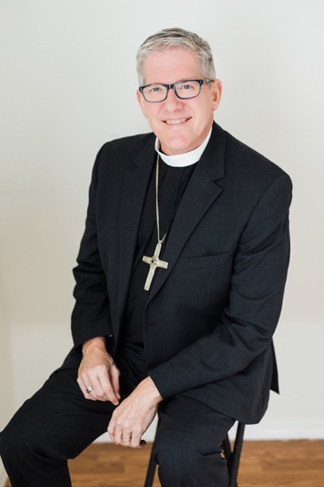
Together we can do something about it!
I invite you to take part in the Gulf Coast Synod’s Emergency Winter Freeze Appeal, raising $100,000 to rebuild lives and buildings.
It's not just about serving, any organization can do it. As a church we are called to serve and evangelize. Show the face of Christ to others.

~Rev. Gabriel Marcaño, Sagrada Familia/Kinsmen Lutheran Church, Houston

You may make a gift ONLINE at: https://gulfcoastsynod.org/emergency-winter-freeze-appeal/ or scan this QR code to be taken directly there.

TEXT the word give to 956-275-7659.
You’ll be sent a text with a link to register.
Click on that link and enter your information.

MAIL a check to:
Texas-Louisiana Gulf Coast Synod
12941 I-45 North Freeway, Suite 210
Houston, TX 77060
Please note: Emergency Winter Freeze Appeal on the memo line.
Together we can do something about it!
I invite you to take part in the Gulf Coast Synod’s Emergency Winter Freeze Appeal, raising $100,000 to rebuild lives and buildings.
It's not just about serving, any organization can do it. As a church we are called to serve and evangelize. Show the face of Christ to others.

~Rev. Gabriel Marcaño, Sagrada Familia/Kinsmen Lutheran Church, Houston

You may make a gift ONLINE at: https://gulfcoastsynod.org/emergency-winter-freeze-appeal/ or scan this QR code to be taken directly there.

TEXT the word give to 956-275-7659.
You’ll be sent a text with a link to register.
Click on that link and enter your information.

MAIL a check to:
Texas-Louisiana Gulf Coast Synod
12941 I-45 North Freeway, Suite 210
Houston, TX 77060
Please note: Emergency Winter Freeze Appeal on the memo line.

